1. **INTRODUCTION**
   1. *overview*
      * *Description of the project*

Project Description:

* 1. TravelTrax Tours, a tour operator, leverages Zoho Books to manage their bookings, track expenses, and handle invoicing for their customers. They can generate professional invoices, reconcile payments, and monitor their financial performance. Zoho Books helps them streamline their financial operations and enhance customer service

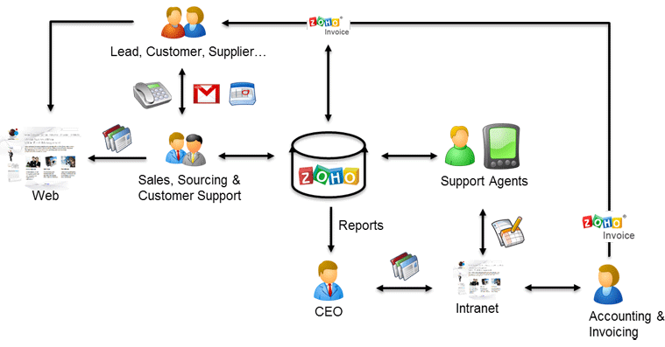

As a Center of Excellence, HealthHub Clinics offers multi-disciplinary resources and smart healthcare solutions, supported by a holistic and compassionate approach, understanding and quality care designed around your health.

1. **Problem definition & design Thinking**
   1. *Empathy map*

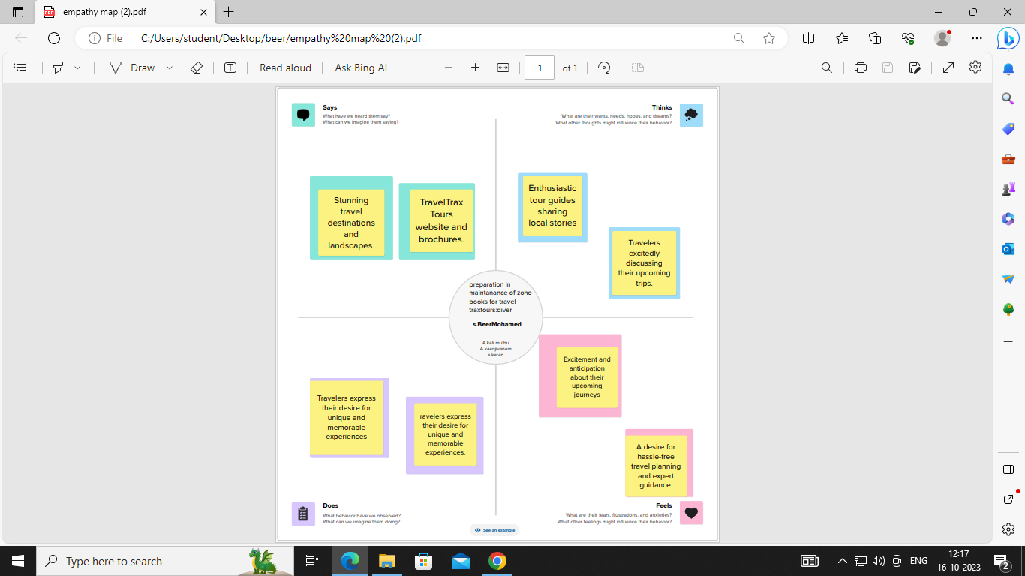

* 1. *Ideation & Brainstorming map*

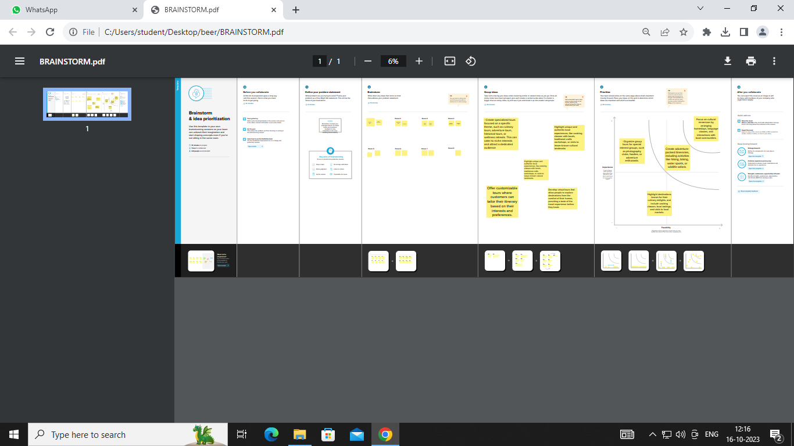

1. **Result Profit&loss**

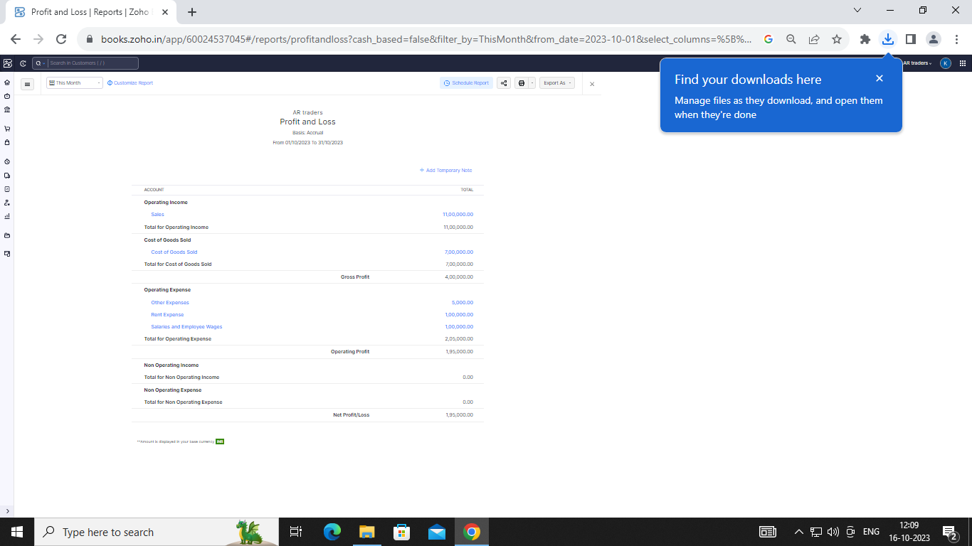

Balance sheet:

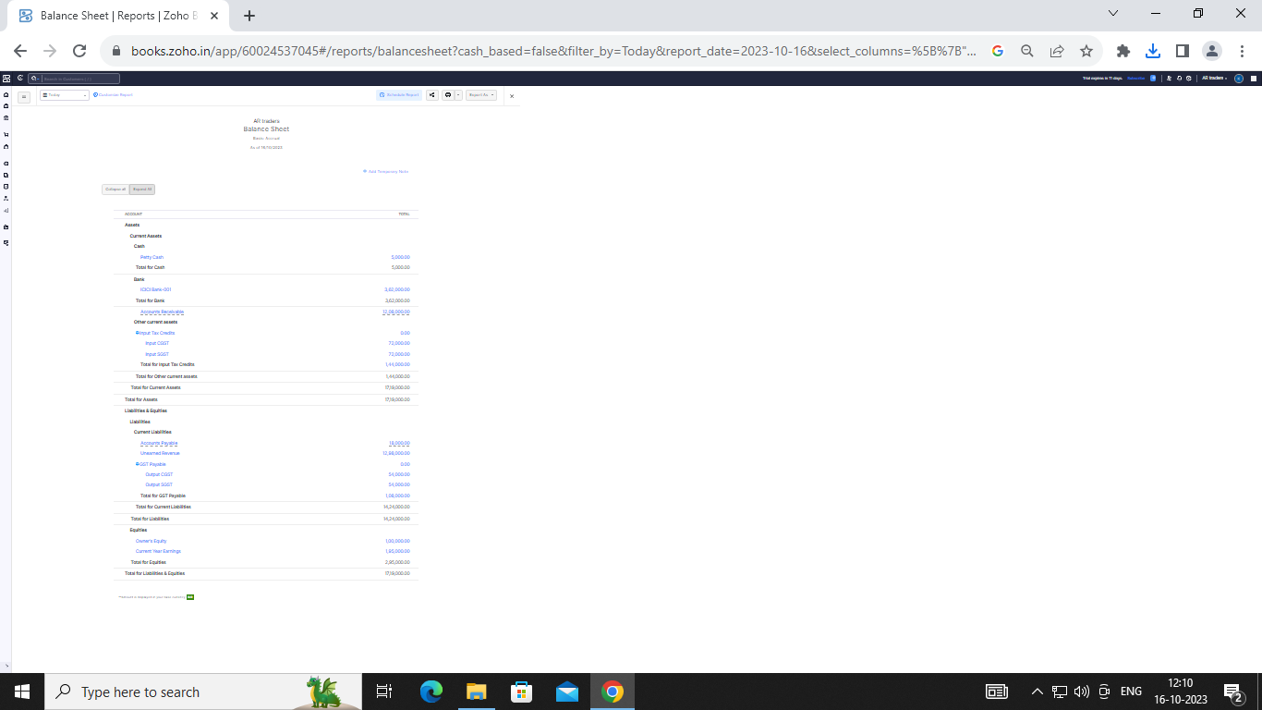

Purchase order:

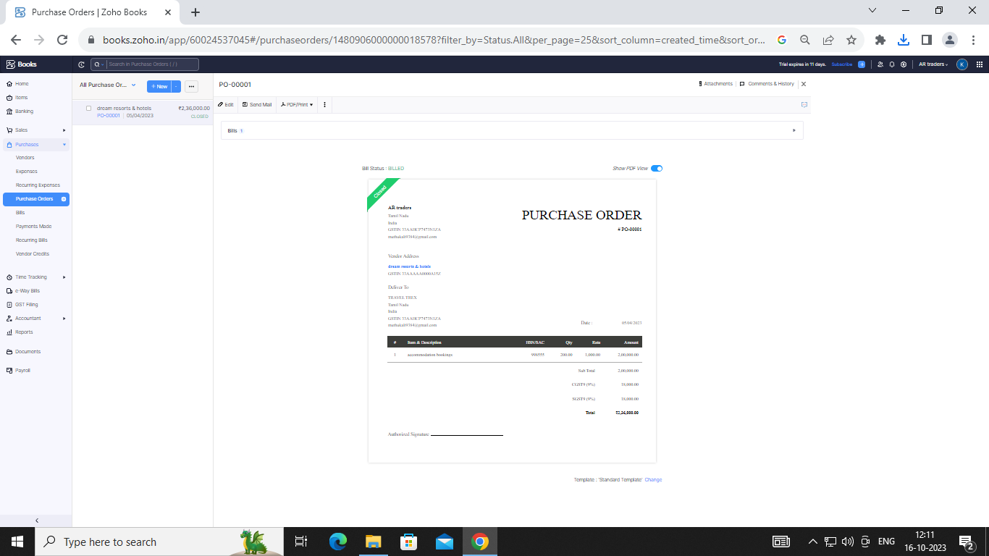

Sales order:

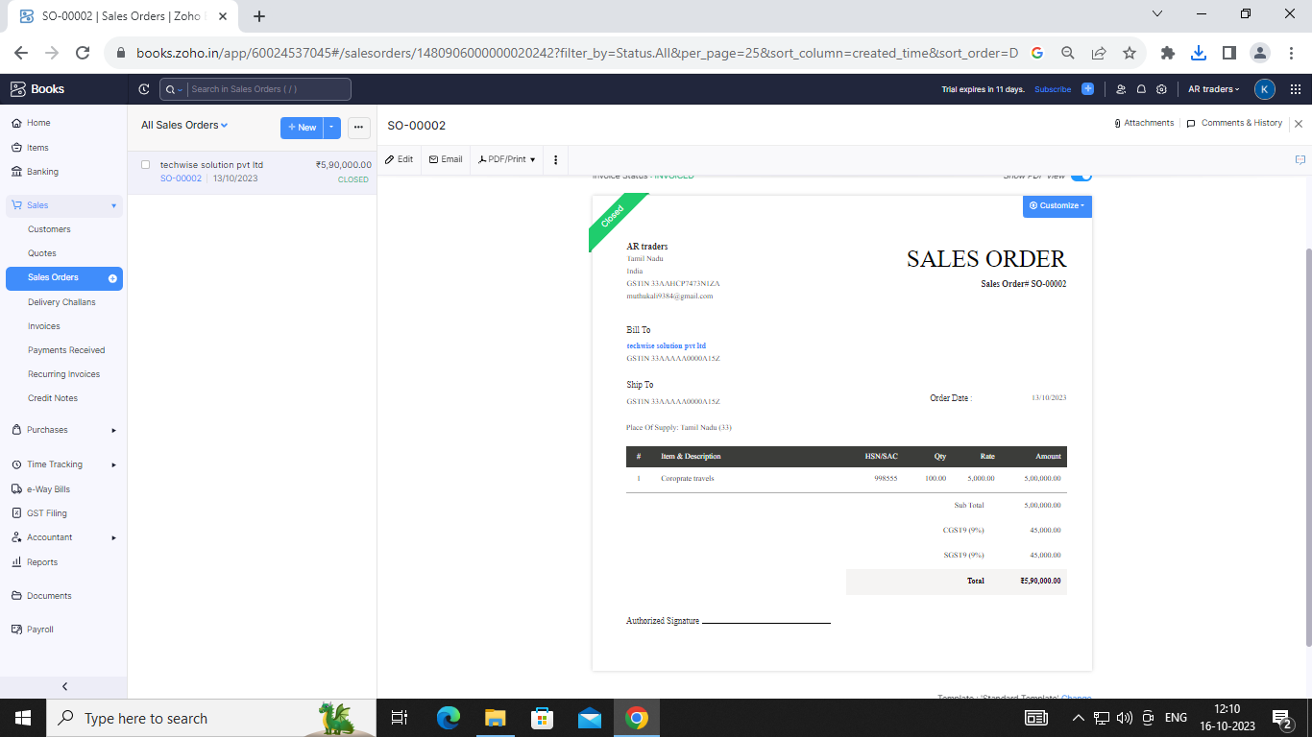

Invoice:

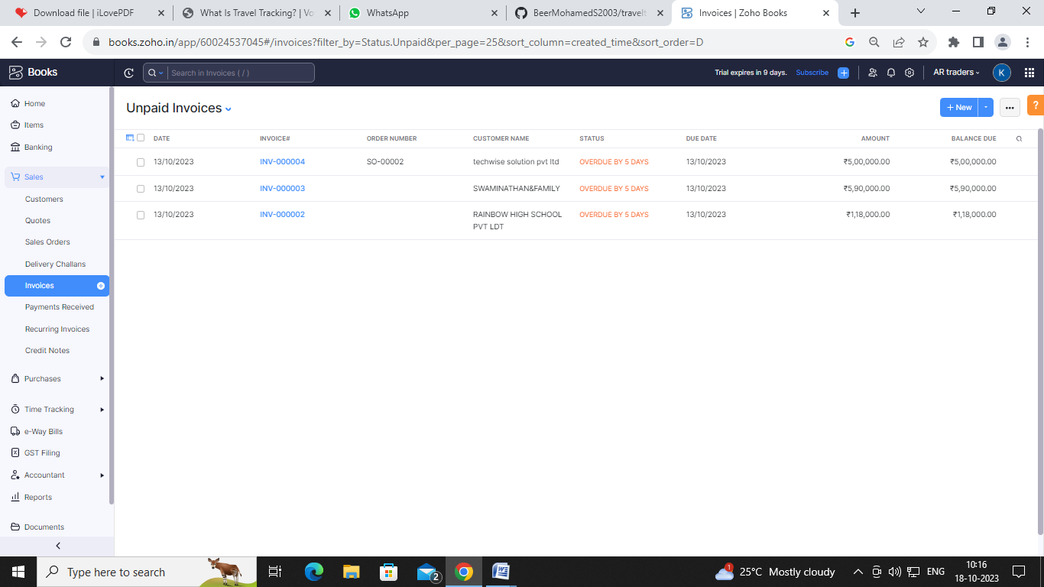

Bills:

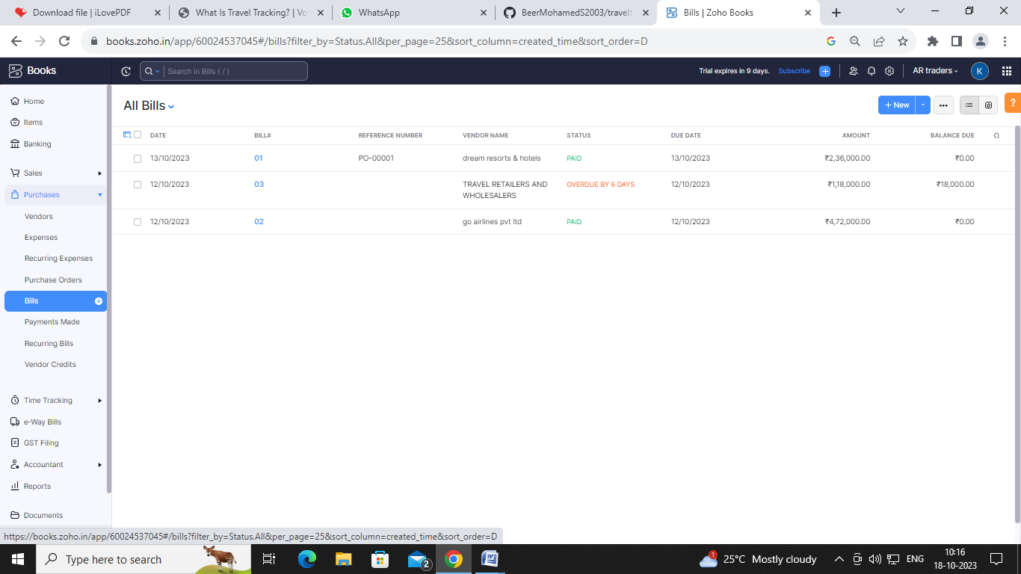

ADVANTAGES OF TRAVELTRAX TOURS :

Travel tracking offers many benefits for both personal and business travel. Safety is one of the main benefits as it's easier to keep travelers safe if you know where they are, respond to incidents faster, and provide medical support. Tax compliance is another benefit as it makes gathering the data a tax accountant needs to file accurate tax returns much more straightforward. Immigration compliance is another benefit, as travel tracking can help ensure compliance with immigration laws and regulations. Carbon tracking is also a benefit as it can generate a carbon emission record that can form the basis of an offsetting or carbon reduction program. Lastly, cost-saving is another benefit as travelers and employers can identify areas where they can save money, such as sticking to one airline and its loyalty program, and consolidating trips.

DISADVANTAGES OF HEALTHHUB MEDICAL CLINIC:

1. **Can be Costly** – Traveling often comes with a hefty price tag, including costs for transportation, accommodation, food, and activities.
2. **Causes Stress** – Planning a trip, navigating unfamiliar places, and dealing with unexpected obstacles can be stressful and take a toll on one’s mental and physical health.
3. **Can Lead to Culture Shock** – Immersing yourself in a new culture can be overwhelming and cause culture shock, making it difficult to adjust to new surroundings.
4. *APPLICATIONS:*
5. **TRAVELTRAX TOURS**
6. **Conclusion:**

“Travel and tourisim management” simplifies the management process in travelling . Fast processing and immediate results with high security. Minimizing human effort and cost efficient databases. Navigation through the site is easy.

1. **FUTURE SCOPE:**

We will inculde more functionlity as per the user requirements. We want to improved our home page, as it is the main thing which attracts all user.

1. **APPENDIX:**

<https://github.com/BeerMohamedS2003/traveltrax-tours_NM2023TMID23119>

|  |
| --- |
|  |
| <!DOCTYPE html> |
|  | <html lang="en" data-color-mode="auto" data-light-theme="light" data-dark-theme="dark" data-a11y-animated-images="system" data-a11y-link-underlines="false"> |
|  |  |
|  | <style> |
|  | /* for each iteration, uncomment the CSS variable */ |
|  |  |
|  | /* light themes */ |
|  | [data-color-mode="light"][data-light-theme*="light"], |
|  | [data-color-mode="auto"][data-light-theme*="light"] { |
|  | /* iteration 1 */ |
|  | --border-color-iteration-1: #C8CCD0; |
|  | /* iteration 2 */ |
|  | --border-color-iteration-2: #BABFC5; |
|  | /* iteration 3 */ |
|  | --border-color-iteration-3: #A6ADB4; |
|  | /* iteration final */ |
|  | --border-color-iteration-4: #868F99; |
|  |  |
|  | /* the first value is the final step, which falls back to previous iterations */ |
|  | --control-borderColor-rest: var(--border-color-iteration-4, var(--border-color-iteration-3, var(--border-color-iteration-2, var(--border-color-iteration-1)))) !important; |
|  | } |
|  |  |
|  | /* dark themes */ |
|  | [data-color-mode="dark"][data-dark-theme*="dark"], |
|  | [data-color-mode="auto"][data-light-theme*="dark"] { |
|  | /* iteration 1 */ |
|  | --border-color-iteration-1: #363940; |
|  | /* iteration 2 */ |
|  | --border-color-iteration-2: #3F434B; |
|  | /* iteration 3 */ |
|  | --border-color-iteration-3: #4B5159; |
|  | /* iteration final */ |
|  | --border-color-iteration-4: #666E79; |
|  |  |
|  | /* the first value is the final step, which falls back to previous iterations */ |
|  | --control-borderColor-rest: var(--border-color-iteration-4, var(--border-color-iteration-3, var(--border-color-iteration-2, var(--border-color-iteration-1)))) !important; |
|  | } |
|  |  |
|  | [data-color-mode="dark"][data-dark-theme="dark_dimmed"], |
|  | [data-color-mode="dark"][data-dark-theme="light_high_contrast"], |
|  | [data-color-mode="dark"][data-dark-theme="dark_high_contrast"], |
|  | [data-color-mode="light"][data-light-theme="dark_dimmed"], |
|  | [data-color-mode="light"][data-light-theme="light_high_contrast"], |
|  | [data-color-mode="light"][data-light-theme="dark_high_contrast"] { |
|  | /* skip these themes, use the fallback */ |
|  | --control-borderColor-rest: initial !important; |
|  | } |
|  |  |
|  | @media (prefers-color-scheme: dark) { |
|  | /* dark colors in dark mode */ |
|  | [data-color-mode="auto"][data-dark-theme*="dark"] { |
|  | /* iteration 1 */ |
|  | --border-color-iteration-1: #363940; |
|  | /* iteration 2 */ |
|  | --border-color-iteration-2: #3F434B; |
|  | /* iteration 3 */ |
|  | --border-color-iteration-3: #4B5159; |
|  | /* iteration final */ |
|  | --border-color-iteration-4: #666E79; |
|  |  |
|  | /* the first value is the final step, which falls back to previous iterations */ |
|  | --control-borderColor-rest: var(--border-color-iteration-4, var(--border-color-iteration-3, var(--border-color-iteration-2, var(--border-color-iteration-1)))) !important; |
|  | } |
|  |  |
|  | /* light colors in dark mode */ |
|  | [data-color-mode="auto"][data-dark-theme*="light"] { |
|  | /* iteration 1 */ |
|  | --border-color-iteration-1: #C8CCD0; |
|  | /* iteration 2 */ |
|  | --border-color-iteration-2: #BABFC5; |
|  | /* iteration 3 */ |
|  | --border-color-iteration-3: #A6ADB4; |
|  | /* iteration final */ |
|  | --border-color-iteration-4: #868F99; |
|  |  |
|  | /* the first value is the final step, which falls back to previous iterations */ |
|  | --control-borderColor-rest: var(--border-color-iteration-4, var(--border-color-iteration-3, var(--border-color-iteration-2, var(--border-color-iteration-1)))) !important; |
|  | } |
|  |  |
|  | [data-color-mode="auto"][data-dark-theme="dark_dimmed"], |
|  | [data-color-mode="auto"][data-dark-theme="light_high_contrast"], |
|  | [data-color-mode="auto"][data-dark-theme="dark_high_contrast"] { |
|  | /* skip these themes, use the fallback */ |
|  | --control-borderColor-rest: initial !important; |
|  | } |
|  | } |
|  |  |
|  | @media (prefers-color-scheme: light) { |
|  | /* dark colors in light mode */ |
|  | [data-color-mode="auto"][data-light-theme*="dark"] { |
|  | /* iteration 1 */ |
|  | --border-color-iteration-1: #363940; |
|  | /* iteration 2 */ |
|  | --border-color-iteration-2: #3F434B; |
|  | /* iteration 3 */ |
|  | --border-color-iteration-3: #4B5159; |
|  | /* iteration final */ |
|  | --border-color-iteration-4: #666E79; |
|  |  |
|  | /* the first value is the final step, which falls back to previous iterations */ |
|  | --control-borderColor-rest: var(--border-color-iteration-4, var(--border-color-iteration-3, var(--border-color-iteration-2, var(--border-color-iteration-1)))) !important; |
|  | } |
|  |  |
|  | /* light colors in light mode */ |
|  | [data-color-mode="auto"][data-light-theme*="light"] { |
|  | /* iteration 1 */ |
|  | --border-color-iteration-1: #C8CCD0; |
|  | /* iteration 2 */ |
|  | --border-color-iteration-2: #BABFC5; |
|  | /* iteration 3 */ |
|  | --border-color-iteration-3: #A6ADB4; |
|  | /* iteration final */ |
|  | --border-color-iteration-4: #868F99; |
|  |  |
|  | /* the first value is the final step, which falls back to previous iterations */ |
|  | --control-borderColor-rest: var(--border-color-iteration-4, var(--border-color-iteration-3, var(--border-color-iteration-2, var(--border-color-iteration-1)))) !important; |
|  | } |
|  |  |
|  | [data-color-mode="auto"][data-light-theme="dark_dimmed"], |
|  | [data-color-mode="auto"][data-light-theme="light_high_contrast"], |
|  | [data-color-mode="auto"][data-light-theme="dark_high_contrast"] { |
|  | /* skip these themes, use the fallback */ |
|  | --control-borderColor-rest: initial !important; |
|  | } |
|  | } |
|  | </style> |
|  |  |

rel=”stylesheet”

data-href=https://github.githubassets.com/assets/dark_high_contrast-8438e75afd36.css><lin k data-color-theme=”dark_colorblind” crossorigin=”anonymous” media=”all” rel=”stylesheet” data-href=https://github.githubassets.com/assets/dark_colorblind-bf5665b96628.css><link data-color-theme=”light_colorblind” crossorigin=”anonymous” media=”all” rel=”stylesheet” data-href=https://github.githubassets.com/assets/light_colorblind-c414b5ba1dce.css><link data-color-theme=”light_high_contrast” crossorigin=”anonymous” media=”all” rel=”stylesheet”

data-href=https://github.githubassets.com/assets/light_high_contrast-e5868b7374db.css><lin k data-color-theme=”light_tritanopia” crossorigin=”anonymous” media=”all” rel=”stylesheet” data-href=https://github.githubassets.com/assets/light_tritanopia-299ac9c64ec0.css><link data-color-theme=”dark_tritanopia” crossorigin=”anonymous” media=”all” rel=”stylesheet” data-href=h[ttps://github.githubassets.com/assets/dark_tritanopia-3a26e78ad0ff.css>](https://github.githubassets.com/assets/light_high_contrast-e5868b7374db.css)

<link cros[sorigin=”anonymous” media=”all” rel=”stylesheet”](https://github.githubassets.com/assets/dark_tritanopia-3a26e78ad0ff.css) href=”./NM2023TMID22539_profit_and_loss.pdf at main · asmku643mku643c1c31260_NM2023TMID22539 · GitHub_files/primer-primitives-6143c8f97ed1.css”>

<link crossorigin=”anonymous” media=”all” rel=”stylesheet” href=”./NM2023TMID22539_profit_and_loss.pdf at main · asmku643mku643c1c31260_NM2023TMID22539 · GitHub_files/primer-d6dcdf72e61d.css”>

<link crossorigin=”anonymous” media=”all” rel=”stylesheet” href=”./NM2023TMID22539_profit_and_loss.pdf at main · asmku643mku643c1c31260_NM2023TMID22539 · GitHub_files/global-ab1c3e3e5644.css”>

<link crossorigin=”anonymous” media=”all” rel=”stylesheet” href=”./NM2023TMID22539_profit_and_loss.pdf at main · asmku643mku643c1c31260_NM2023TMID22539 · GitHub_files/github-757ef6ea9a38.css”>

<link crossorigin=”anonymous” media=”all” rel=”stylesheet” href=”./NM2023TMID22539_profit_and_loss.pdf at main · asmku643mku643c1c31260_NM2023TMID22539 · GitHub_files/code-71ecd5638fbf.css”>

<script type=”application/json”

id=”client-env”>{“locale”:”en”,”featureFlags”:[“failbot_handle_non_errors”,”geojson_azure_m aps”,”image_metric_tracking”,”turbo_experiment_risky”,”sample_network_conn_type”]}</scri pt>

<script crossorigin=”anonymous” defer=”defer” type=”application/javascript” src=”./NM2023TMID22539_profit_and_loss.pdf at main · asmku643mku643c1c31260_NM2023TMID22539 ·

GitHub_files/wp-runtime-86f14561f3b0.js.download”></script>

<script crossorigin=”anonymous” defer=”defer” type=”application/javascript” src=”./NM2023TMID22539_profit_and_loss.pdf at main · asmku643mku643c1c31260_NM2023TMID22539 ·

GitHub_files/vendors-node_modules_dompurify_dist_purify_js-64d590970fa6.js.download”>

</script>

<script crossorigin=”anonymous” defer=”defer” type=”application/javascript” src=”./NM2023TMID22539_profit_and_loss.pdf at main · asmku643mku643c1c31260_NM2023TMID22539 ·

GitHub_files/vendors-node_modules_stacktrace-parser_dist_stack-trace-parser_esm_js-node_ modules_github_bro-a4c183-18bf85b8e9f4.js.download”></script>

<script crossorigin=”anonymous” defer=”defer” type=”application/javascript” src=”./NM2023TMID22539_profit_and_loss.pdf at main · asmku643mku643c1c31260_NM2023TMID22539 ·

GitHub_files/ui_packages_soft-nav_soft-nav_ts-56133143b228.js.download”></script>

<script crossorigin=”anonymous” defer=”defer” type=”application/javascript” src=”./NM2023TMID22539_profit_and_loss.pdf at main · asmku643mku643c1c31260_NM2023TMID22539 ·

GitHub_files/environment-fc6543d75794.js.download”></script>

<script crossorigin=”anonymous” defer=”defer” type=”application/javascript” src=”./NM2023TMID22539_profit_and_loss.pdf at main · asmku643mku643c1c31260_NM2023TMID22539 ·

GitHub_files/vendors-node_modules_github_selector-observer_dist_index_esm_js-2646a2c53 3e3.js.download”></script>

<script crossorigin=”anonymous” defer=”defer” type=”application/javascript” src=”./NM2023TMID22539_profit_and_loss.pdf at main · asmku643mku643c1c31260_NM2023TMID22539 ·

GitHub_files/vendors-node_modules_primer_behaviors_dist_esm_focus-zone_js-d55308df50 23.js.download”></script>

<script crossorigin=”anonymous” defer=”defer” type=”application/javascript” src=”./NM2023TMID22539_profit_and_loss.pdf at main · asmku643mku643c1c31260_NM2023TMID22539 ·

GitHub_files/vendors-node_modules_github_relative-time-element_dist_index_js-99e288659 d4f.js.download”></script>

<script crossorigin=”anonymous” defer=”defer” type=”application/javascript” src=”./NM2023TMID22539_profit_and_loss.pdf at main · asmku643mku643c1c31260_NM2023TMID22539 ·

GitHub_files/vendors-node_modules_fzy_js_index_js-node_modules_github_combobox-nav_ dist_index_js-node_modu-344bff-91b70bb50d68.js.download”></script>

<script crossorigin=”anonymous” defer=”defer” type=”application/javascript” src=”./NM2023TMID22539_profit_and_loss.pdf at main · asmku643mku643c1c31260_NM2023TMID22539 ·

GitHub_files/vendors-node_modules_delegated-events_dist_index_js-node_modules_github_ auto-complete-element-81d69b-f766607dc0c8.js.download”></script>

<script crossorigin=”anonymous” defer=”defer” type=”application/javascript” src=”./NM2023TMID22539_profit_and_loss.pdf at main · asmku643mku643c1c31260_NM2023TMID22539 ·

GitHub_files/vendors-node_modules_github_filter-input-element_dist_index_js-node_module s_github_remote-inp-2e8678-d593bf262480.js.download”></script>

<script crossorigin=”anonymous” defer=”defer” type=”application/javascript” src=”./NM2023TMID22539_profit_and_loss.pdf at main · asmku643mku643c1c31260_NM2023TMID22539 ·

GitHub_files/vendors-node_modules_github_file-attachment-element_dist_index_js-node_m odules_primer_view-co-70ad06-9f8bb7e4a8fa.js.download”></script>

<script crossorigin=”anonymous” defer=”defer” type=”application/javascript” src=”./NM2023TMID22539_profit_and_loss.pdf at main · asmku643mku643c1c31260_NM2023TMID22539 ·

GitHub_files/github-elements-30961cfd137b.js.download”></script>

<script crossorigin=”anonymous” defer=”defer” type=”application/javascript” src=”./NM2023TMID22539_profit_and_loss.pdf at main · asmku643mku643c1c31260_NM2023TMID22539 ·

GitHub_files/element-registry-e5f51987a7c5.js.download”></script>

<script crossorigin=”anonymous” defer=”defer” type=”application/javascript” src=”./NM2023TMID22539_profit_and_loss.pdf at main · asmku643mku643c1c31260_NM2023TMID22539 ·

GitHub_files/vendors-node_modules_lit-html_lit-html_js-4ccebb6ebf7d.js.download”></script

>

<script crossorigin=”anonymous” defer=”defer” type=”application/javascript” src=”./NM2023TMID22539_profit_and_loss.pdf at main · asmku643mku643c1c31260_NM2023TMID22539 ·

GitHub_files/vendors-node_modules_github_mini-throttle_dist_index_js-node_modules_gith ub_alive-client_dist-bf5aa2-504c8d53fb8e.js.download”></script>

<script crossorigin=”anonymous” defer=”defer” type=”application/javascript” src=”./NM2023TMID22539_profit_and_loss.pdf at main · asmku643mku643c1c31260_NM2023TMID22539 ·

GitHub_files/vendors-node_modules_morphdom_dist_morphdom-esm_js-b1fdd7158cf0.js.do wnload”></script>

<script crossorigin=”anonymous” defer=”defer” type=”application/javascript” src=”./NM2023TMID22539_profit_and_loss.pdf at main · asmku643mku643c1c31260_NM2023TMID22539 ·

GitHub_files/vendors-node_modules_github_turbo_dist_turbo_es2017-esm_js-9a3541181451

.js.download”></script>

<script crossorigin=”anonymous” defer=”defer” type=”application/javascript” src=”./NM2023TMID22539_profit_and_loss.pdf at main · asmku643mku643c1c31260_NM2023TMID22539 ·

GitHub_files/vendors-node_modules_github_remote-form_dist_index_js-node_modules_scrol l-anchoring_dist_scro-52dc4b-e1e33bfc0b7e.js.download”></script>

<script crossorigin=”anonymous” defer=”defer” type=”application/javascript” src=”./NM2023TMID22539_profit_and_loss.pdf at main · asmku643mku643c1c31260_NM2023TMID22539 ·

GitHub_files/vendors-node_modules_color-convert_index_js-35b3ae68c408.js.download”></s cript>

<script crossorigin=”anonymous” defer=”defer” type=”application/javascript” src=”./NM2023TMID22539_profit_and_loss.pdf at main · asmku643mku643c1c31260_NM2023TMID22539 ·

GitHub_files/vendors-node_modules_primer_behaviors_dist_esm_dimensions_js-node_modu les_github_jtml_lib_index_js-a18147cea3a6.js.download”></script>

<script crossorigin=”anonymous” defer=”defer” type=”application/javascript” src=”./NM2023TMID22539_profit_and_loss.pdf at main ·

asmku643mku643c1c31260_NM2023TMID22539 ·

GitHub_files/vendors-node_modules_github_paste-markdown_dist_index_esm_js-node_mod ules_github_quote-select-581a1f-4a3074d34892.js.download”></script>

<script crossorigin=”anonymous” defer=”defer” type=”application/javascript” src=”./NM2023TMID22539_profit_and_loss.pdf at main · asmku643mku643c1c31260_NM2023TMID22539 · GitHub_files/app_assets_modules_github_details-dialog_ts-app_assets_modules_github_fetc h_ts-add1ab03ecb3.js.download”></script>

<script crossorigin=”anonymous” defer=”defer” type=”application/javascript” src=”./NM2023TMID22539_profit_and_loss.pdf at main · asmku643mku643c1c31260_NM2023TMID22539 · GitHub_files/app_assets_modules_github_updatable-content_ts-ui_packages_hydro-analytics

_hydro-analytics_ts-0a5a30c9b976.js.download”></script>

<script crossorigin=”anonymous” defer=”defer” type=”application/javascript” src=”./NM2023TMID22539_profit_and_loss.pdf at main · asmku643mku643c1c31260_NM2023TMID22539 · GitHub_files/app_assets_modules_github_onfocus_ts-app_assets_modules_github_sticky-scr oll-into-view_ts-c56a5dfc8975.js.download”></script>

<script crossorigin=”anonymous” defer=”defer” type=”application/javascript” src=”./NM2023TMID22539_profit_and_loss.pdf at main · asmku643mku643c1c31260_NM2023TMID22539 · GitHub_files/app_assets_modules_github_behaviors_task-list_ts-app_assets_modules_github

_sso_ts-ui_packages-7d50ad-9491f2be61ee.js.download”></script>

<script crossorigin=”anonymous” defer=”defer” type=”application/javascript” src=”./NM2023TMID22539_profit_and_loss.pdf at main · asmku643mku643c1c31260_NM2023TMID22539 · GitHub_files/app_assets_modules_github_behaviors_ajax-error_ts-app_assets_modules_gith ub_behaviors_include-2e2258-d77f85c54572.js.download”></script>

<script crossorigin=”anonymous” defer=”defer” type=”application/javascript” src=”./NM2023TMID22539_profit_and_loss.pdf at main · asmku643mku643c1c31260_NM2023TMID22539 · GitHub_files/app_assets_modules_github_behaviors_commenting_edit_ts-app_assets_modul es_github_behaviors_ht-83c235-f22ac6b94445.js.download”></script>

<script crossorigin=”anonymous” defer=”defer” type=”application/javascript” src=”./NM2023TMID22539_profit_and_loss.pdf at main · asmku643mku643c1c31260_NM2023TMID22539 ·

GitHub_files/behaviors-8e3546d05c82.js.download”></script>

<script crossorigin=”anonymous” defer=”defer” type=”application/javascript” src=”./NM2023TMID22539_profit_and_loss.pdf at main · asmku643mku643c1c31260_NM2023TMID22539 ·

GitHub_files/vendors-node_modules_delegated-events_dist_index_js-node_modules_github_ catalyst_lib_index_js-623425af41e1.js.download”></script>

<script crossorigin=”anonymous” defer=”defer” type=”application/javascript” src=”./NM2023TMID22539_profit_and_loss.pdf at main · asmku643mku643c1c31260_NM2023TMID22539 ·

GitHub_files/notifications-global-0104a8043aa4.js.download”></script>

<script crossorigin=”anonymous” defer=”defer” type=”application/javascript” src=”./NM2023TMID22539_profit_and_loss.pdf at main · asmku643mku643c1c31260_NM2023TMID22539 ·

GitHub_files/vendors-node_modules_optimizely_optimizely-sdk_dist_optimizely_browser_es

_min_js-node_modules-089adc-8794271c9a65.js.download”></script>

<script crossorigin=”anonymous” defer=”defer” type=”application/javascript” src=”./NM2023TMID22539_profit_and_loss.pdf at main · asmku643mku643c1c31260_NM2023TMID22539 ·

GitHub_files/optimizely-b8ae60018b11.js.download”></script>

<script crossorigin=”anonymous” defer=”defer” type=”application/javascript” src=”./NM2023TMID22539_profit_and_loss.pdf at main · asmku643mku643c1c31260_NM2023TMID22539 ·

GitHub_files/vendors-node_modules_virtualized-list_es_index_js-node_modules_github_tem plate-parts_lib_index_js-677582870bfd.js.download”></script>

<script crossorigin=”anonymous” defer=”defer” type=”application/javascript” src=”./NM2023TMID22539_profit_and_loss.pdf at main · asmku643mku643c1c31260_NM2023TMID22539 ·

GitHub_files/vendors-node_modules_github_remote-form_dist_index_js-node_modules_dele gated-events_dist_inde-c537341-13ba07af3b2c.js.download”></script>

<script crossorigin=”anonymous” defer=”defer” type=”application/javascript” src=”./NM2023TMID22539_profit_and_loss.pdf at main · asmku643mku643c1c31260_NM2023TMID22539 · GitHub_files/app_assets_modules_github_ref-selector_ts-cad36de2ca60.js.download”></scrip t>

<script crossorigin=”anonymous” defer=”defer” type=”application/javascript” src=”./NM2023TMID22539_profit_and_loss.pdf at main ·

asmku643mku643c1c31260_NM2023TMID22539 · GitHub_files/codespaces-d5d24842ceda.js.download”></script>

<script crossorigin=”anonymous” defer=”defer” type=”application/javascript” src=”./NM2023TMID22539_profit_and_loss.pdf at main · asmku643mku643c1c31260_NM2023TMID22539 ·

GitHub_files/vendors-node_modules_github_filter-input-element_dist_index_js-node_module s_github_mini-throt-08ab15-d50c69097a3e.js.download”></script>

<script crossorigin=”anonymous” defer=”defer” type=”application/javascript” src=”./NM2023TMID22539_profit_and_loss.pdf at main · asmku643mku643c1c31260_NM2023TMID22539 ·

GitHub_files/vendors-node_modules_github_file-attachment-element_dist_index_js-node_m odules_github_mini-th-55cf52-b2acd5425c7c.js.download”></script>

<script crossorigin=”anonymous” defer=”defer” type=”application/javascript” src=”./NM2023TMID22539_profit_and_loss.pdf at main · asmku643mku643c1c31260_NM2023TMID22539 ·

GitHub_files/repositories-b80504a04cf8.js.download”></script>

<script crossorigin=”anonymous” defer=”defer” type=”application/javascript” src=”./NM2023TMID22539_profit_and_loss.pdf at main · asmku643mku643c1c31260_NM2023TMID22539 ·

GitHub_files/vendors-node_modules_github_remote-form_dist_index_js-node_modules_dele gated-events_dist_inde-0e9dbe-6435366f0862.js.download”></script>

<script crossorigin=”anonymous” defer=”defer” type=”application/javascript” src=”./NM2023TMID22539_profit_and_loss.pdf at main · asmku643mku643c1c31260_NM2023TMID22539 ·

GitHub_files/topic-suggestions-2e55863e3751.js.download”></script>

<script crossorigin=”anonymous” defer=”defer” type=”application/javascript” src=”./NM2023TMID22539_profit_and_loss.pdf at main · asmku643mku643c1c31260_NM2023TMID22539 ·

GitHub_files/code-menu-6bd50a0647d6.js.download”></script>

<meta http-equiv=”x-pjax-version” content=”d98aab6b69dc43e4407b1369c7bbfcf76dfab2d839011937153201c9b943f42f” data-turbo-track=”reload”>

<meta http-equiv=”x-pjax-csp-version” content=”ee14a7165914197d62e19f664bfb961fcfdfc1ec31939a5c7b137fbab1751c87” data-turbo-track=”reload”>

<meta http-equiv=”x-pjax-css-version” content=”664233c3fea08fdf2ac6994c09da8d00c5e5f750fe523a7605f44e0aafe71afe” data-turbo-track=”reload”>

<meta http-equiv=”x-pjax-js-version” content=”dd74378fedb3de5476a9fb9b72cce29ed416c09618bddd59f59777f848393889” data-turbo-track=”reload”>

<style type=”text/css” id=”operaUserStyle”></style>

<script type=”application/javascript” src=”./NM2023TMID22539_profit_and_loss.pdf at main

· asmku643mku643c1c31260_NM2023TMID22539 · GitHub_files/react-lib-210c4b5934c3.js.download”></script><script

type=”application/javascript” src=”./NM2023TMID22539_profit_and_loss.pdf at main · asmku643mku643c1c31260_NM2023TMID22539 ·

GitHub_files/vendors-node_modules_primer_octicons-react_dist_index_esm_js-node_module s_primer_react_lib-es-3db9ab-5f4faa9f1811.js.download”></script><script type=”application/javascript” src=”./NM2023TMID22539_profit_and_loss.pdf at main · asmku643mku643c1c31260_NM2023TMID22539 ·

GitHub_files/vendors-node_modules_primer_react_lib-esm_Box_Box_js-96a44addc402.js.do wnload”></script><script type=”application/javascript” src=”./NM2023TMID22539_profit_and_loss.pdf at main · asmku643mku643c1c31260_NM2023TMID22539 ·

GitHub_files/vendors-node_modules_primer_react_lib-esm_Button_Button_js-node_modules

_primer_react_lib-esm_-f6da63-1976b80d3486.js.download”></script><script type=”application/javascript” src=”./NM2023TMID22539_profit_and_loss.pdf at main · asmku643mku643c1c31260_NM2023TMID22539 ·

GitHub_files/vendors-node_modules_primer_react_lib-esm_Truncate_Truncate_js-node_mod

ules_primer_react_lib—5d1957-92534314547a.js.download”></script><script type=”application/javascript” src=”./NM2023TMID22539_profit_and_loss.pdf at main · asmku643mku643c1c31260_NM2023TMID22539 ·

GitHub_files/vendors-node_modules_primer_react_lib-esm_Button_index_js-node_modules_ primer_react_lib-esm_O-279bf8-c9a61955d545.js.download”></script><script type=”application/javascript” src=”./NM2023TMID22539_profit_and_loss.pdf at main · asmku643mku643c1c31260_NM2023TMID22539 ·

GitHub_files/vendors-node_modules_primer_react_lib-esm_Text_Text_js-node_modules_pri mer_react_lib-esm_Text-85a14b-0f28951279b7.js.download”></script><script type=”application/javascript” src=”./NM2023TMID22539_profit_and_loss.pdf at main · asmku643mku643c1c31260_NM2023TMID22539 ·

GitHub_files/vendors-node_modules_primer_react_lib-esm_ActionList_index_js-535c8ee1ebe 8.js.download”></script><script type=”application/javascript” src=”./NM2023TMID22539_profit_and_loss.pdf at main · asmku643mku643c1c31260_NM2023TMID22539 ·

GitHub_files/vendors-node_modules_primer_react_lib-esm_ActionMenu_ActionMenu_js-2f0 8ef908241.js.download”></script><script type=”application/javascript” src=”./NM2023TMID22539_profit_and_loss.pdf at main · asmku643mku643c1c31260_NM2023TMID22539 · GitHub_files/vendors-